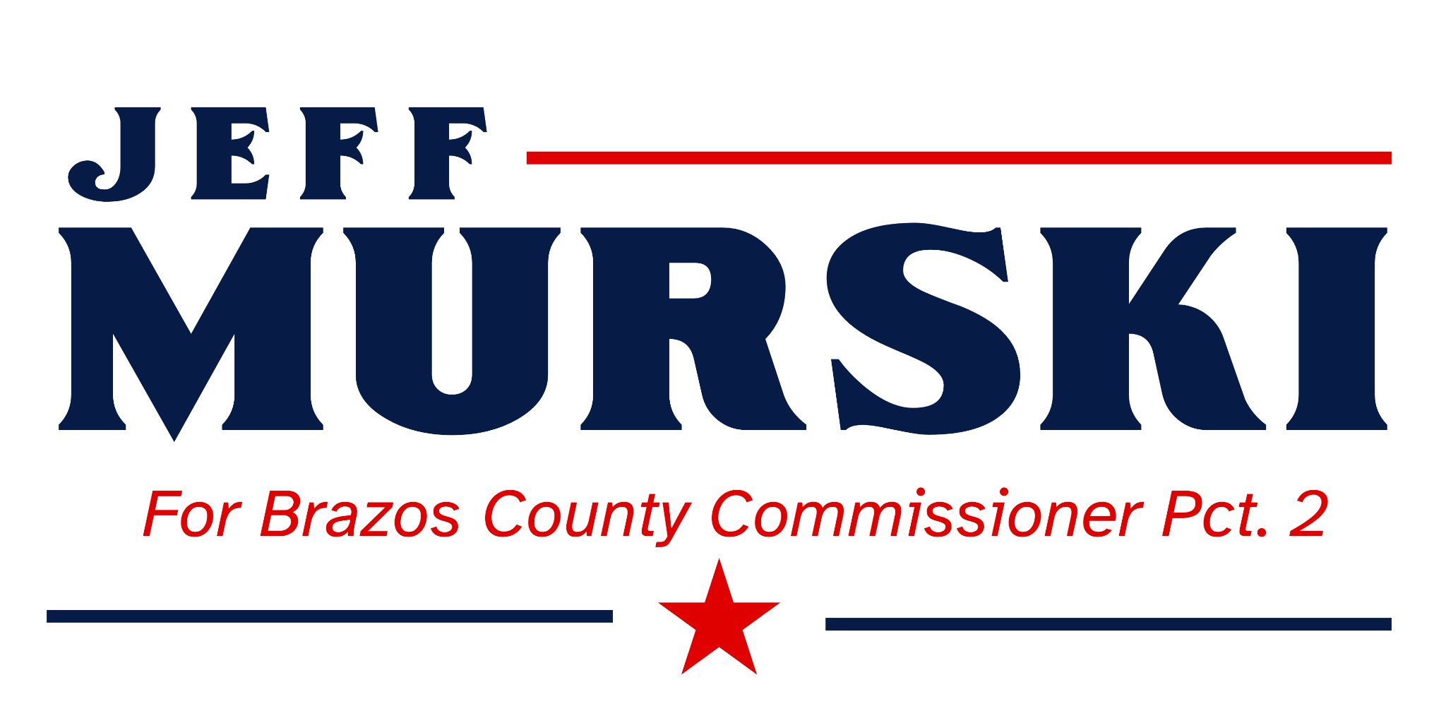 CONTACT: Jeff Murski
murskiforbrazos@gmail.com

FOR IMMEDIATE RELEASE
Tuesday, September 23, 2025

Jeff Murski, Republican for Brazos County Commissioner, Precinct 2 Launches Official Campaign Website

BRAZOS COUNTY, TX - Jeff Murski, Republican Candidate for Brazos County Commissioner Precinct 2 issued the following statement regarding the launch of his official campaign website;

‘My campaign is in full swing, it is important to me that the voter clearly understands my message, vision and desire to connect to them by providing a relevant and easy to navigate ‘mobile friendly’ website. It has resources about ‘key issue areas’ that IMPACT the future success and prosperity of Brazos County.’ I want to make sure that this website will encourage voters to make a DIRECT connection with me.

Instead of just asking for their money, I want Precinct 2 voters to realize I am the most qualified candidate with a cogent campaign plan sharing a vision that is more about being FOR a better future and not simply AGAINST certain ideas, initiatives, and plans that we all may or may not agree with. It will be a long and hard road to victory. I pray that at the end of the day, Precinct 2 will elect a candidate who values rebuilding the TRUST between the Courthouse and ALL residents within Brazos County. For me, that is where it starts, rebuilding and maintaining a strong trust as I desire to be the very best advocate to SERVICE the NEEDS of Precinct 2. As I previously shared in my July 7th announcement, I will focus on these four areas;
- Taxes: Tax revenue to continues to rise over what our needs require.
- Advocacy: Servicing the needs of the Voter is important to me. This will be my full-time job.
- Operational efficiencies: It is easy to go after taxes; it is hard to go after efficiencies. I am confident of untapped efficiencies that can be discovered.
- Transparency and Priorities: I will be reachable and responsive with your best interests at heart.
I want to help make Brazos better again. I want to FIX, not FIGHT. I am determined to help our County Government function better and govern well with GROWTH and PROSPERITY for ALL Citizens in Brazos County.

For more information about my campaign, schedule an interview or host a meet and greet, please visit murskiforbrazos.com or directly email me at murskiforbrazos@gmail.com . As my website has gone live, my plan will continue to go into action reaching out to you and your neighbors. I covet your prayers and ask for your vote. March 3, 2026, will be here before you know it.
God Bless Brazos County.

